数据：

Movielens：1m-ml；

Movies: Movie title,id,genre（including crawling posters，credits，plot ，year in backend real-time using IMDBpie API ）,and we remove the non-english terms of movie titles.

Rating,user;

算法：

Try User-based，svd，item-based (implemented in the backend)

Simple present the algorithms .

Evaluation:

In order to optimize our recommendation result, we precompute the different MSE result using 3 different algorithems and the result s shows :

So we decide to use item-based .

MSE

Python result:

Demo implement:

We used Python Django as backend to implement our project.

1. Enviroment setup:

Window10 , Python 3.6.4, mysql 5.7.21,mysql bench 6.3 CE

1. Python Requiremnt pacakges

Numpy ,pandas, imdbpie ,Imdbpy, sklearn

App start up by

Python manage.py runserver 8080

Open in the browser 127.0.0.1:8080

Login-page：

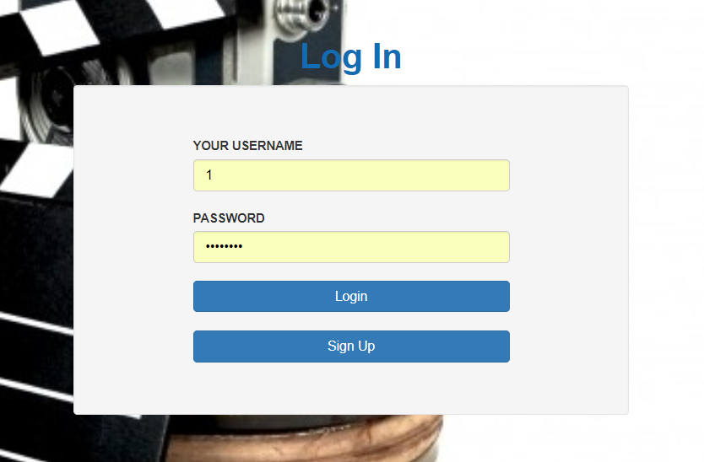

Homepage：

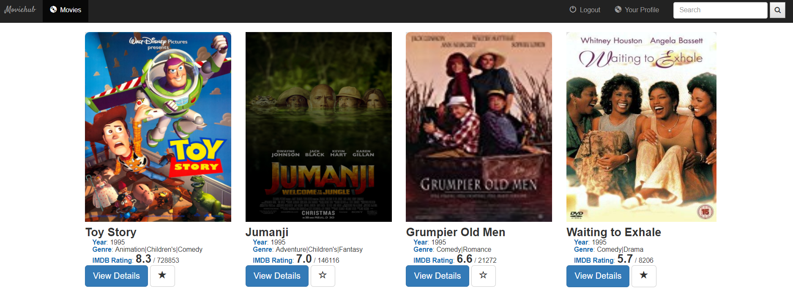

Search:

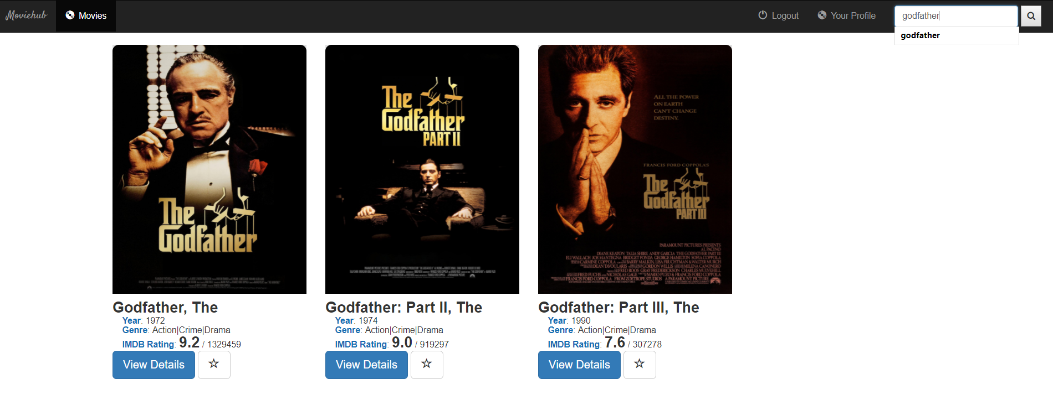

Movie detail：

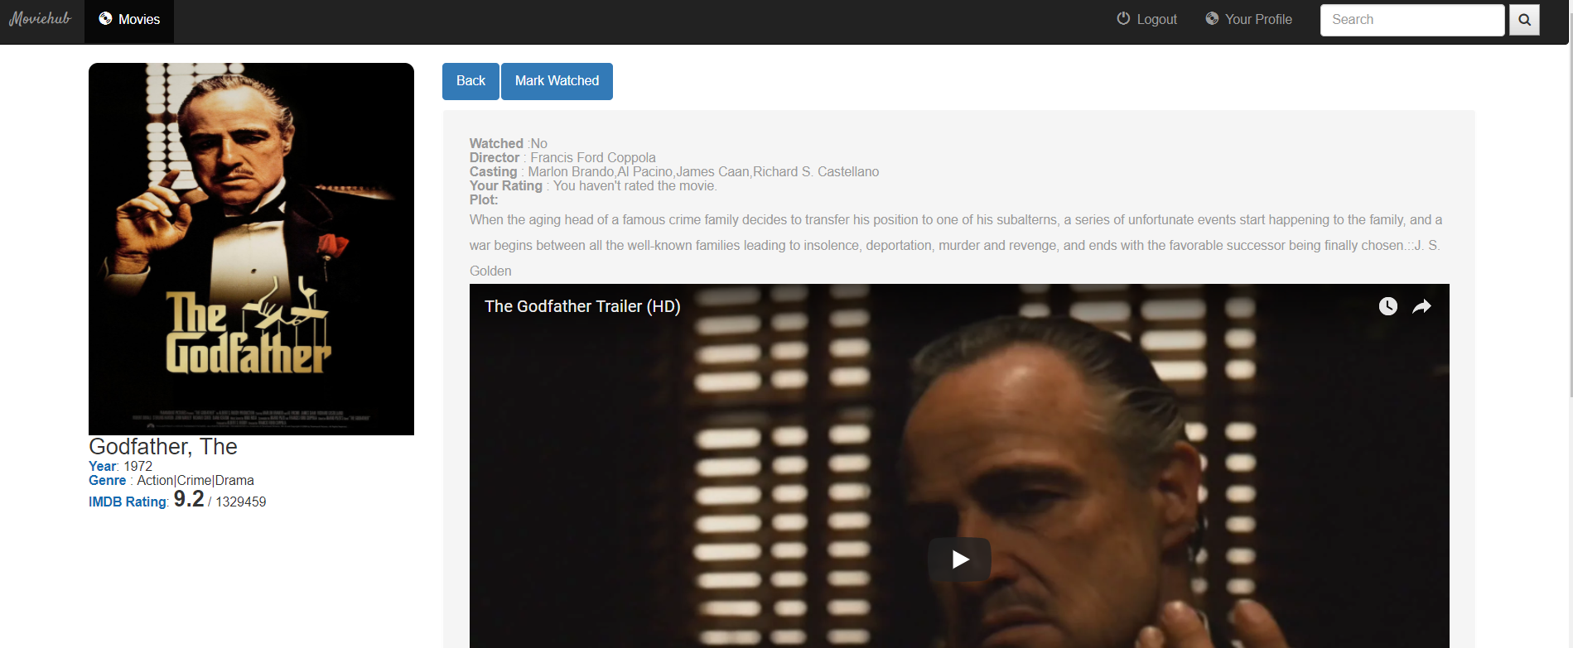

Recommend similar movies：

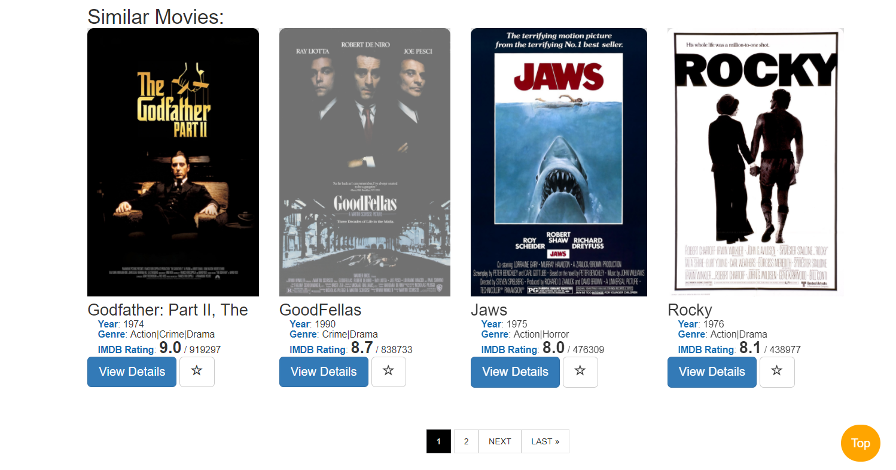

User homepage：

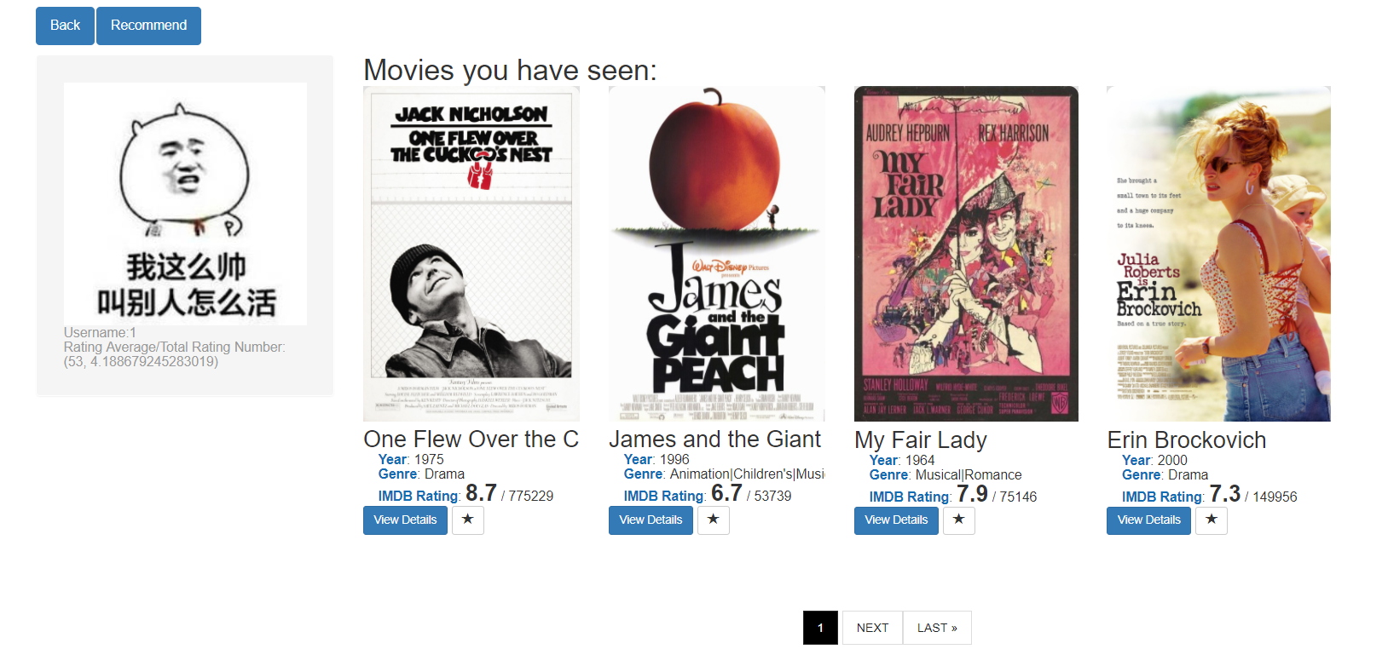

Recommend movie to user based on item-based:

